Portal Page Site Plan

Lauren Fura

WDD 130

Overview

Purpose:

Showcase my work completed in WDD 130.

Audience:

Anyone who would like to see what I worked on in WDD 130.

Branding

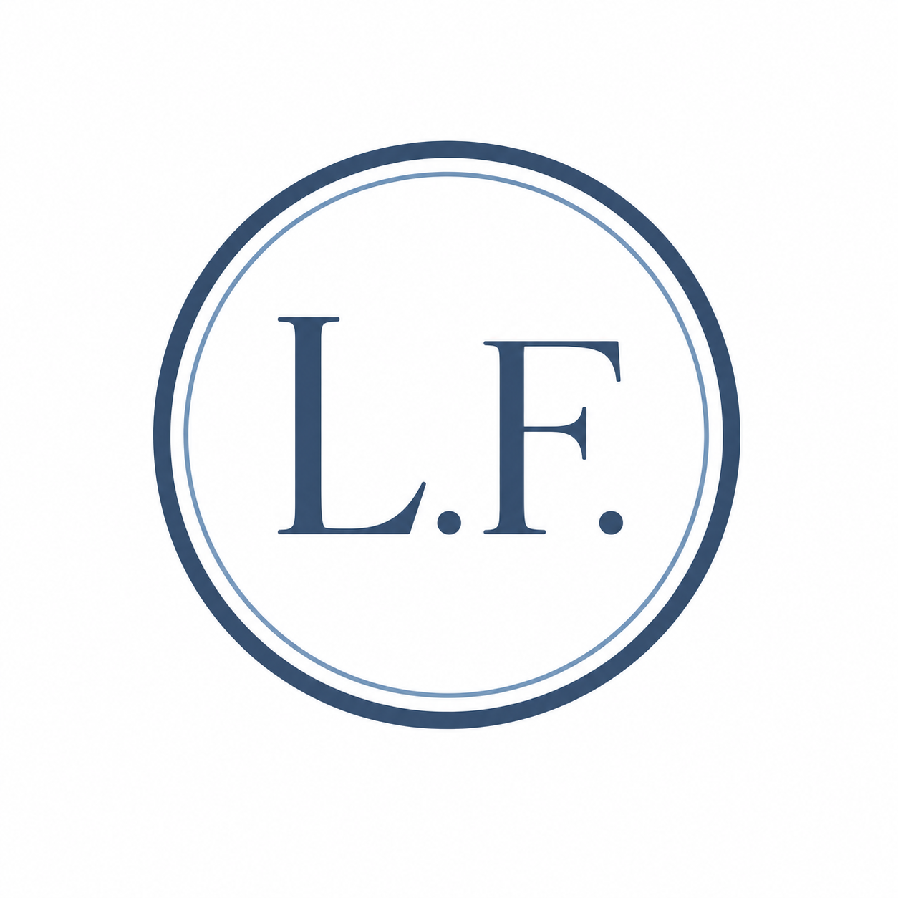
Website Logo

Style Guide

Color Palette

Primary | Secondary | Accent 1 | Accent 2 | Accent 3

Typography

Heading font: Playfair Display

Paragraph font: Montserrat

Normal paragraph example

Lorem ipsum dolor sit amet, consectetur adipiscing elit, sed do eiusmod tempor incididunt ut labore et dolore magna aliqua. Quis occaecat duis commodo proident deserunt id id. Cupidatat sed commodo cupidatat elit ex adipiscing ut officia proident exercitation.

Colored paragraph example

Lorem ipsum dolor sit amet, consectetur adipiscing elit, sed do eiusmod tempor incididunt ut labore et dolore magna aliqua. Quis occaecat duis commodo proident deserunt id id. Cupidatat sed commodo cupidatat elit ex adipiscing ut officia proident exercitation.

Wireframe:



